|  |  |
| --- | --- |
| EGC_Black | **MATHEMATICS:SPECIALIST**  **SEMESTER 1 2016**  **TEST 2**  **Calculator Free**  **Time Allowed: 20 minutes Total Marks: 19** |

Question 1 (5 marks)

(a) Determine a unit vector perpendicular to the vector . (2 marks)

(b) The point P divides the line segment from M(-3, 3) to N(13, -9) in the ratio 1:3. Determine the position vector of point P. (3 marks)

Question 2 (6 marks)

The statement 'if two rectangles are congruent then they have the same area' is true.

(a) Write the inverse of the statement and explain whether or not the inverse is also true.

(2 marks)

(b) Write the contrapositive of the statement and explain whether or not the contrapositive is also true. (2 marks)

(c) Write the converse of the statement and explain whether or not the converse is also true.

(2 marks)

Question 3 (4 marks)

If a = 2i +j and b = -3i +2j, find *m* and *n* such that *m*a + *n*b = -2i + 6j.

Question 4 (4 marks)

Use the method of contradiction to prove that a triangle with sides of 5 cm, 5 cm and 7 cm is not right angled.

|  |  |
| --- | --- |
| EGC_Black | **MATHEMATICS:SPECIALIST**  **SEMESTER 1 2016**  **TEST 2**  **Calculator Assumed**  **Time Allowed: 40 Total Marks: 35** |

Question 5 (5 marks)

Three vectors are given by ,  and .

(a) Use your calculator to determine the angle between , to the nearest degree.

(2 marks)

(b) Determine all possible values of  if  and  are perpendicular. (3 marks)

Question 6 (8 marks)

Three forces are applied to a body. One has magnitude 300 N and acts due south. Another has magnitude 250 N and acts on a bearing of 050º.

1. If all three forces are in equilibrium, determine the magnitude and direction of the third force.

(4 marks)

(b) If the third force has a magnitude of 350 N and acts on a bearing of 250º, determine the magnitude and direction of the resultant force. (4 marks)

Question 7 (6 marks)

(a) A triangle  has vertices ,  and . Determine the vector,  where M is the midpoint of side . (3 marks)

(b)  is a triangle with point  on side  such that . If 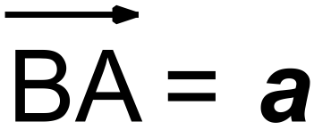 and 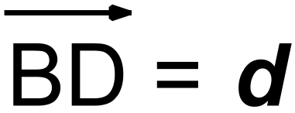 , show that 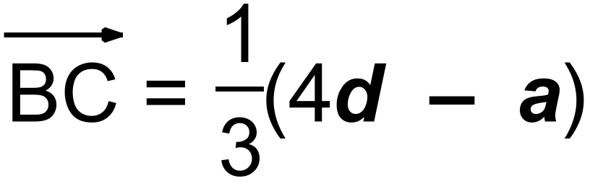 (3 marks)

Question 8 (9 marks)

(a) A small body A has position (12, -3) m relative to another small body B. If a third small body C has position (-5, 6) relative to A, determine the position of B relative to C.

(2 marks)

(b) To a cyclist moving with velocity (21, -5) km/h the wind appears to have velocity (-9, 3) km/h. Determine the true speed of the wind. (3 marks)

(c) A small ship is travelling with a constant speed of 14 knots on a bearing of 025º and another, larger ship is travelling with a constant speed of 17 knots on a bearing of 310º.

Determine the velocity of the large ship relative to the small ship. (4 marks)

Question 9 (7 marks)

A small boat has to travel across a river from  to , where  and . A uniform current of  is flowing in the river and the boat can maintain a steady speed of 4 m/s.

(a) Determine, in the form , the velocity vector the small boat should set to travel directly from  to . (5 marks)

(b) Calculate, to the nearest minute and second, how long the journey will take. (2 marks)